Lagged cross-correlation: EURUSD and EURGBP
Method 12 / daily log returns / K_max=10 / Alpari D1 full available history

Study setup
Logical pair: EURUSD , EURGBP
Broker symbols: EURUSD_i , EURGBP_i
Snapshot: 2026-11-03_majors_alpari_D1
Timeframe: D1
Matched return window: 1999-01-06 to 2026-11-02 (UTC bar dates)
Matched return count n: 7183
Dropped unfinished last bar dated 2026-11-03 UTC after a tick-volume check against the prior complete day.
Lag definition: rho_X->Y(k) = Corr(x_t, y_{t+k}) on matched D1 bars
K_max = 10; headline lag k = 1 (both directions)
Complete matched rows (Excel): EURUSD-EURGBP_Lagged_D1.xlsx
Complete matched rows (HTML table): EURUSD-EURGBP_Lagged_D1_data.html

Method carried forward
Lagged cross-correlation measures Pearson correlation between matched daily log returns of close, ln(close_t / close_t-1), after shifting one series forward by k bars on the matched panel. Quotes are not inverted. rho_{X->Y}(k) = Corr(x_t, y_{t+k}) with n_k = n - k. K_max = 10 is fixed before estimation. The headline is the pre-specified lag k = 1 in both directions. k = 0 is the same-bar side check. The lag inside 1..10 with the largest absolute rho is stored as a descriptive column only; it is not a selected result. This is a linear screen, not proof of forecast edge, economic cause, or a trading signal.

Results (headline k=1)
rho_EURUSD->EURGBP(1): -0.033320 (n=7182)
95% Fisher interval EURUSD->EURGBP: [-0.056405, -0.010200]
rho_EURGBP->EURUSD(1): -0.004064 (n=7182)
95% Fisher interval EURGBP->EURUSD: [-0.027190, 0.019066]
Same-bar rho(k=0): 0.439899
Largest |rho| among k=1..10 (descriptive only, not selected): EURUSD->EURGBP k=9 rho=-0.041662; EURGBP->EURUSD k=8 rho=0.025964

CCF table
k | rho_EURUSD_to_EURGBP | n_EURUSD_to_EURGBP | rho_EURGBP_to_EURUSD | n_EURGBP_to_EURUSD
0 | 0.43989866 | 7183 | 0.43989866 | 7183
1 | -0.03332021 | 7182 | -0.00406408 | 7182
2 | -0.02056862 | 7181 | 0.00030885 | 7181
3 | -0.00512728 | 7180 | -0.01737175 | 7180
4 | -0.00467843 | 7179 | 0.0151962 | 7179
5 | 0.02633242 | 7178 | 0.01631308 | 7178
6 | -0.01731353 | 7177 | 0.01712227 | 7177
7 | -0.01062482 | 7176 | -0.00155168 | 7176
8 | -0.01022785 | 7175 | 0.02596378 | 7175
9 | -0.04166249 | 7174 | 0.0024986 | 7174
10 | -0.00257448 | 7173 | 0.0194774 | 7173

Conclusion
At the pre-specified lag k=1 for EURUSD and EURGBP, rho_{EURUSD->EURGBP}(1) = -0.0333 (n=7182) and rho_{EURGBP->EURUSD}(1) = -0.0041 (n=7182). Same-bar rho(k=0) = 0.4399. Largest |rho| among k=1..10 is descriptive only: EURUSD->EURGBP at k=9 (-0.0417); EURGBP->EURUSD at k=8 (0.0260). This is a linear screen, not forecast proof or a trading signal.

Charts
Daily closes

Daily log returns

CCF both directions k=0..10
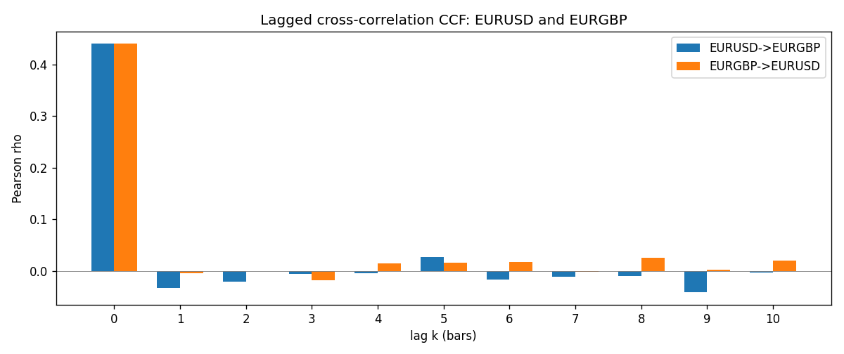

Data report
Every matched row is stored in the sibling Excel workbook named EURUSD-EURGBP_Lagged_D1.xlsx (sheet matched_rows). The CCF sheet holds rho(k) for k=0..10. Embedding all rows as a Word table is impractical; the Word file holds column summaries and the first and last 15 rows.
Columns: time, EURUSD_open, EURGBP_open, EURUSD_high, EURGBP_high, EURUSD_low, EURGBP_low, EURUSD_close, EURGBP_close, EURUSD_tick_volume, EURGBP_tick_volume, EURUSD_spread, EURGBP_spread, EURUSD_real_volume, EURGBP_real_volume, EURUSD_log_return, EURGBP_log_return
Column summaries (matched calculation rows)
column | count | mean | std | min | 25% | 50% | 75% | max
EURUSD_open | 7183 | 1.1815763 | 0.15079461 | 0.8272 | 1.08621 | 1.16623 | 1.29409 | 1.5995
EURGBP_open | 7183 | 0.78698868 | 0.09663692 | 0.5734 | 0.6877 | 0.83389 | 0.86522 | 0.9769
EURUSD_high | 7183 | 1.1867072 | 0.15139096 | 0.8326 | 1.09029 | 1.17134 | 1.29941 | 1.6038
EURGBP_high | 7183 | 0.79006638 | 0.09701205 | 0.5789 | 0.6897 | 0.8369 | 0.8681 | 0.9799
EURUSD_low | 7183 | 1.1765677 | 0.15011491 | 0.8227 | 1.08209 | 1.16259 | 1.288515 | 1.5865
EURGBP_low | 7183 | 0.78428899 | 0.09645396 | 0.5682 | 0.6857 | 0.83166 | 0.86287 | 0.9661
EURUSD_close | 7183 | 1.1816163 | 0.15076829 | 0.8267 | 1.086135 | 1.16619 | 1.2941 | 1.5997
EURGBP_close | 7183 | 0.78703222 | 0.09663758 | 0.5735 | 0.6878 | 0.83395 | 0.86536 | 0.977
EURUSD_tick_volume | 7183 | 103246.15 | 173560.03 | 218 | 9420.5 | 52790 | 99596.5 | 1471626
EURGBP_tick_volume | 7183 | 87133.93 | 145499.42 | 154 | 6594.5 | 44358 | 81413 | 1424684
EURUSD_spread | 7183 | 19.326744 | 16.542159 | 0 | 8 | 12 | 20 | 50
EURGBP_spread | 7183 | 21.324655 | 19.119277 | 0 | 4 | 13 | 40 | 50
EURUSD_real_volume | 7183 | 4.0347326e+10 | 1.669497e+11 | 0 | 0 | 0 | 0 | 3.6149665e+12
EURGBP_real_volume | 7183 | 2.7872287e+10 | 1.3521454e+11 | 0 | 0 | 0 | 0 | 3.5726265e+12
EURUSD_log_return | 7183 | -5.81e-06 | 0.0057996 | -0.03123819 | -0.00324487 | 0 | 0.00325442 | 0.03433183
EURGBP_log_return | 7183 | 2.227e-05 | 0.00487305 | -0.03067367 | -0.00262314 | -9.879e-05 | 0.00256076 | 0.06075387
First 15 matched rows (selected columns)
time | EURUSD_close | EURGBP_close | EURUSD_log_return | EURGBP_log_return
1999-01-06 | 1.1623 | 0.7019 | -0.011547966 | -0.013303338
1999-01-07 | 1.1712 | 0.7097 | 0.0076280636 | 0.011051402
1999-01-08 | 1.1585 | 0.7062 | -0.010902799 | -0.004943862
1999-01-11 | 1.1503 | 0.7053 | -0.007103287 | -0.0012752393
1999-01-12 | 1.1555 | 0.7077 | 0.0045103728 | 0.0033970309
1999-01-13 | 1.1681 | 0.708 | 0.010845346 | 0.00042381861
1999-01-14 | 1.1681 | 0.7066 | 0 | -0.0019793588
1999-01-15 | 1.1563 | 0.7012 | -0.010153245 | -0.0076715819
1999-01-18 | 1.1605 | 0.7017 | 0.0036256946 | 0.00071280921
1999-01-19 | 1.1603 | 0.7007 | -0.00017235436 | -0.0014261269
1999-01-20 | 1.1566 | 0.7021 | -0.0031939256 | 0.0019960086
1999-01-21 | 1.1601 | 0.7016 | 0.0030215416 | -0.00071240297
1999-01-22 | 1.1587 | 0.7004 | -0.0012075213 | -0.0017118406
1999-01-25 | 1.1552 | 0.6966 | -0.0030251979 | -0.0054402425
1999-01-26 | 1.1562 | 0.6962 | 0.00086527651 | -0.00057438255
Last 15 matched rows (selected columns)
time | EURUSD_close | EURGBP_close | EURUSD_log_return | EURGBP_log_return
2026-10-13 | 1.11965 | 0.84458 | 0.0037402957 | 0.00020130374
2026-10-14 | 1.11545 | 0.84553 | -0.0037582255 | 0.0011241873
2026-10-15 | 1.12172 | 0.84479 | 0.0056053107 | -0.00087557391
2026-10-16 | 1.12371 | 0.84307 | 0.0017724895 | -0.0020380844
2026-10-19 | 1.12086 | 0.84259 | -0.0025394633 | -0.00056950988
2026-10-20 | 1.12354 | 0.83957 | 0.0023881672 | -0.0035906254
2026-10-21 | 1.12318 | 0.83839 | -0.00032046717 | -0.00140647
2026-10-22 | 1.12139 | 0.83682 | -0.0015949606 | -0.0018743924
2026-10-23 | 1.11989 | 0.83751 | -0.001338521 | 0.00082421033
2026-10-26 | 1.11735 | 0.83762 | -0.0022706559 | 0.00013133309
2026-10-27 | 1.11272 | 0.83595 | -0.004152342 | -0.0019957343
2026-10-28 | 1.1152 | 0.83651 | 0.0022262927 | 0.00066967224
2026-10-29 | 1.11772 | 0.83553 | 0.0022571351 | -0.0011722209
2026-10-30 | 1.11644 | 0.83351 | -0.0011458446 | -0.0024205543
2026-11-02 | 1.11881 | 0.83426 | 0.002120569 | 0.00089940465

